**Set Up of HANA Trial Account**

*1. HANA Account Creation*

Created a new account and Log into: https://hcp.sap.com/

Please find below my HANA Trial Account login screen shot:

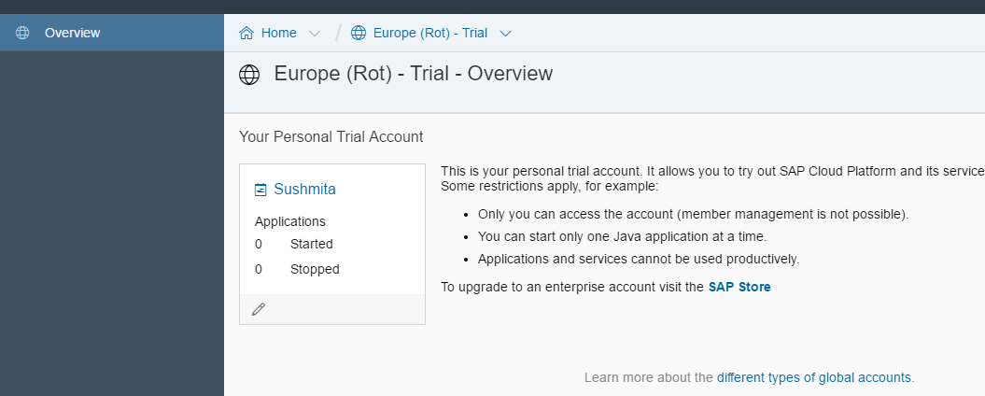

*2. HANA Cloud Trial Database Creation*

HANA Database created.

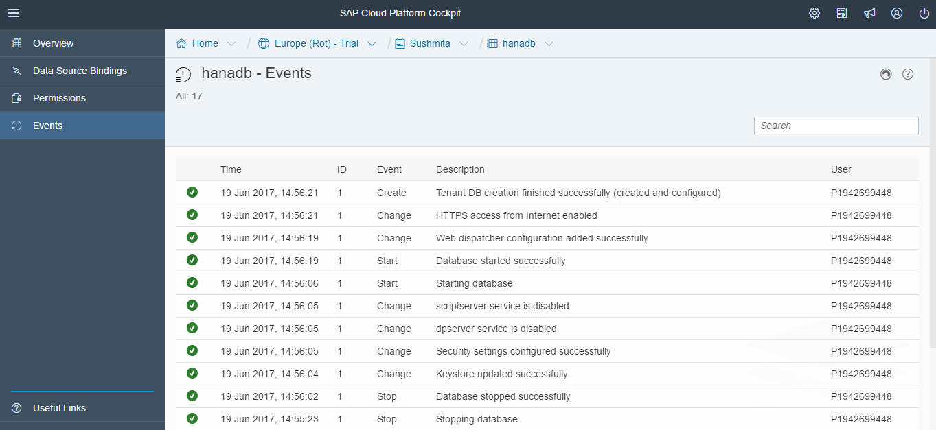

*3. Create developer user for Database*

New user id is created.

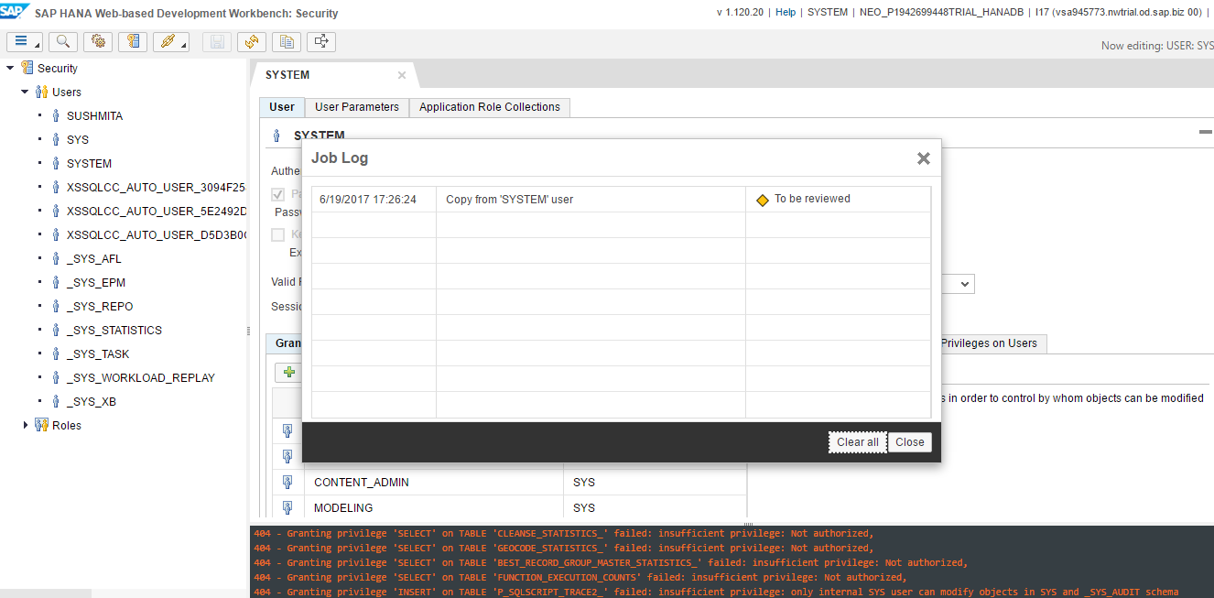

Modeling can now be done using this id either in Web based development workbench or Eclipse.

*4. SAP HANA Web-based Development Workbench*

Accessing Web-based Development Workbench.

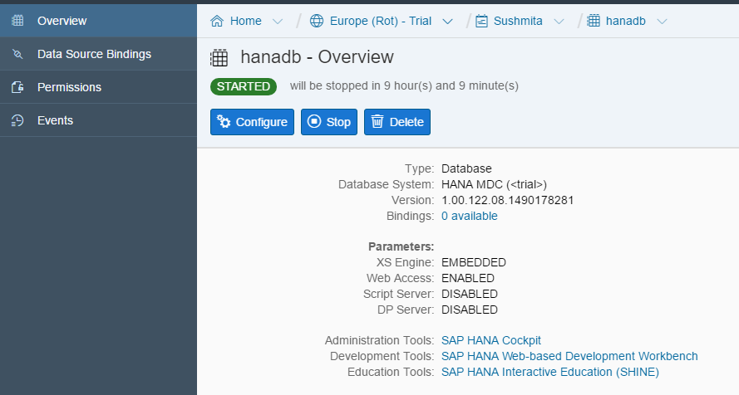

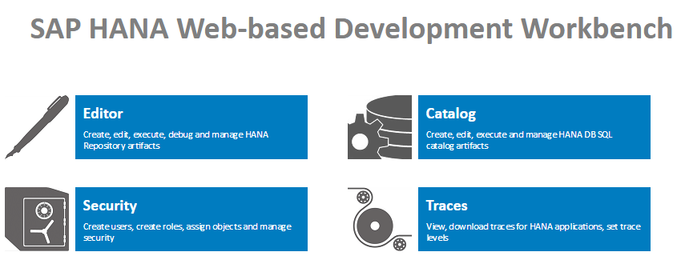

*5.Download Eclipse and set up HANA Account in Eclipse*

The HANA Database is added to eclipse and is ready for HANA Modeling.

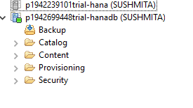

*6. Upload DB Tables in Schema*

Uploaded the table in schema

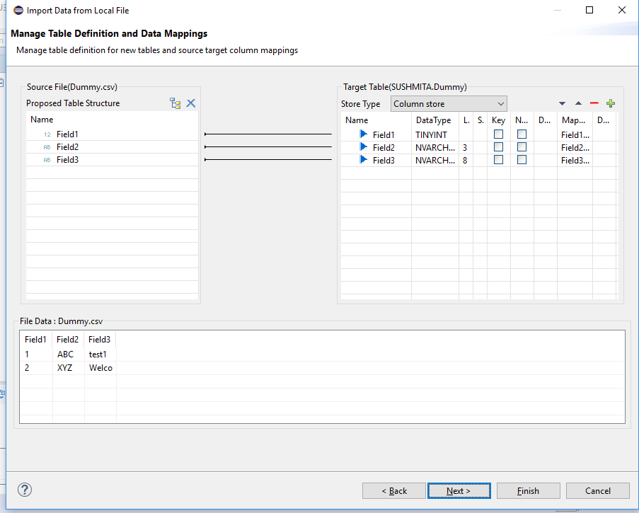

*7. Development Package creation*

Package created in content pane.

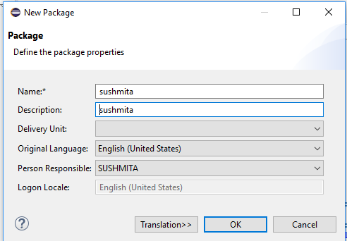

Attribute view created using csv file and data can be preview in data preview

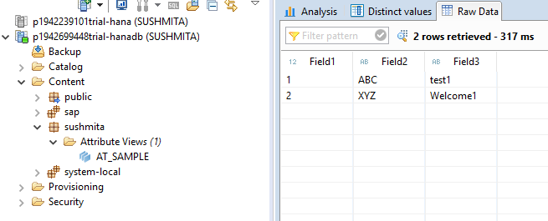

*8. ADD Sample Data (SHINE Demo content) for Modeling*

New schema SAP_HANA_DEMO is available with the entire sample EPM Model data that can be used for modeling.

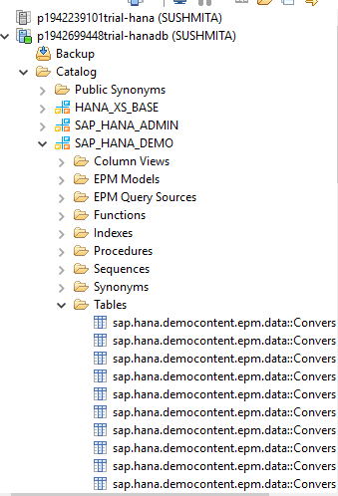

*9. Education Tools SAP HANA Interactive Education (SHINE)*

SHINE contents are available in HANA database.

